How to Create a New Bot
Quick Steps

To create a new bot, go to the Bot Center, then choose Create New Bot.
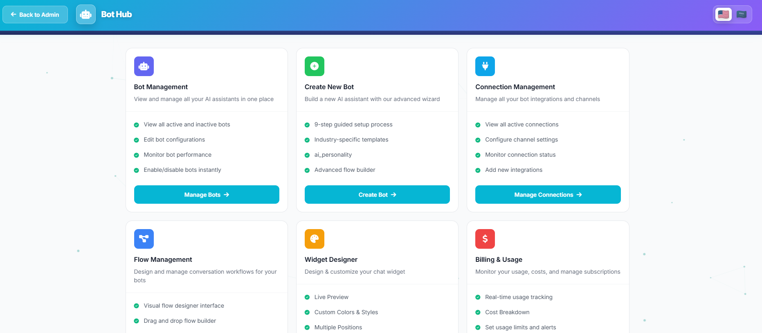

You will find two setup paths: a Quick Setup (4 steps) or a Detailed Setup (12 steps). In general, the more setup steps you complete and the more training data you provide, the better the bot will perform.

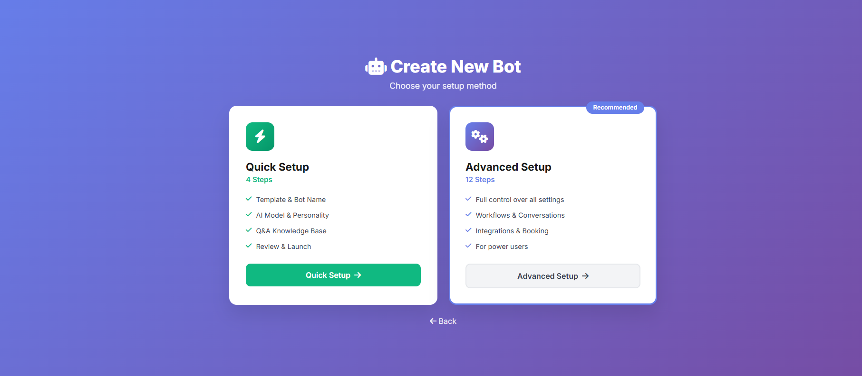
Start by selecting Quick Setup.
Then choose the Bot Identity that matches your business type or brand.

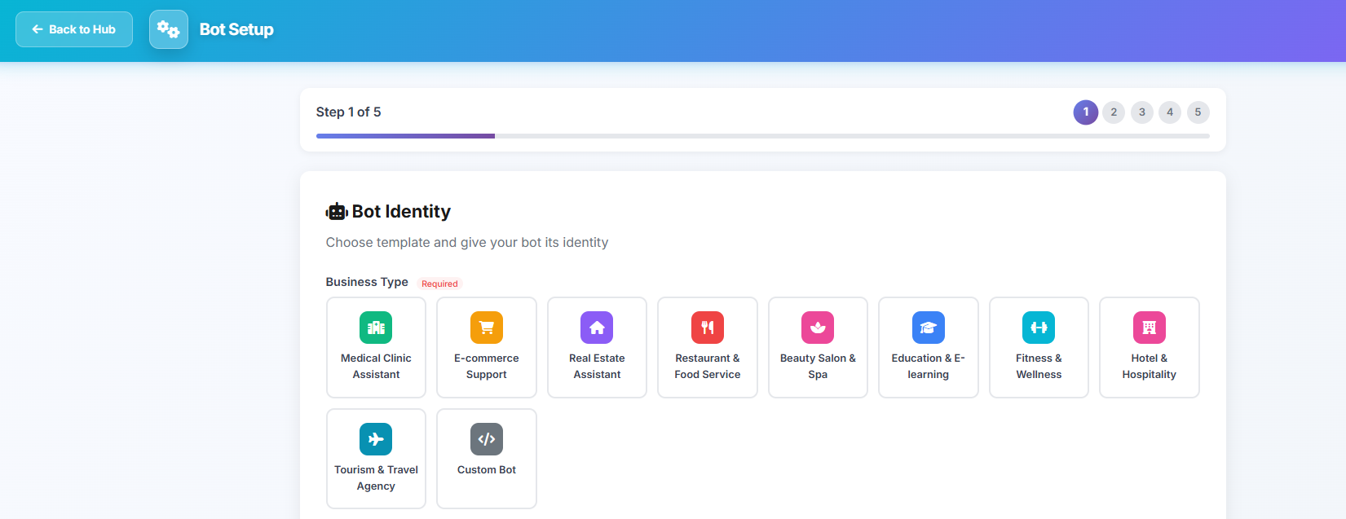
Next, fill in the required details, such as
Company Name, Bot Name, the Language the bot will speak, and a short bot description.

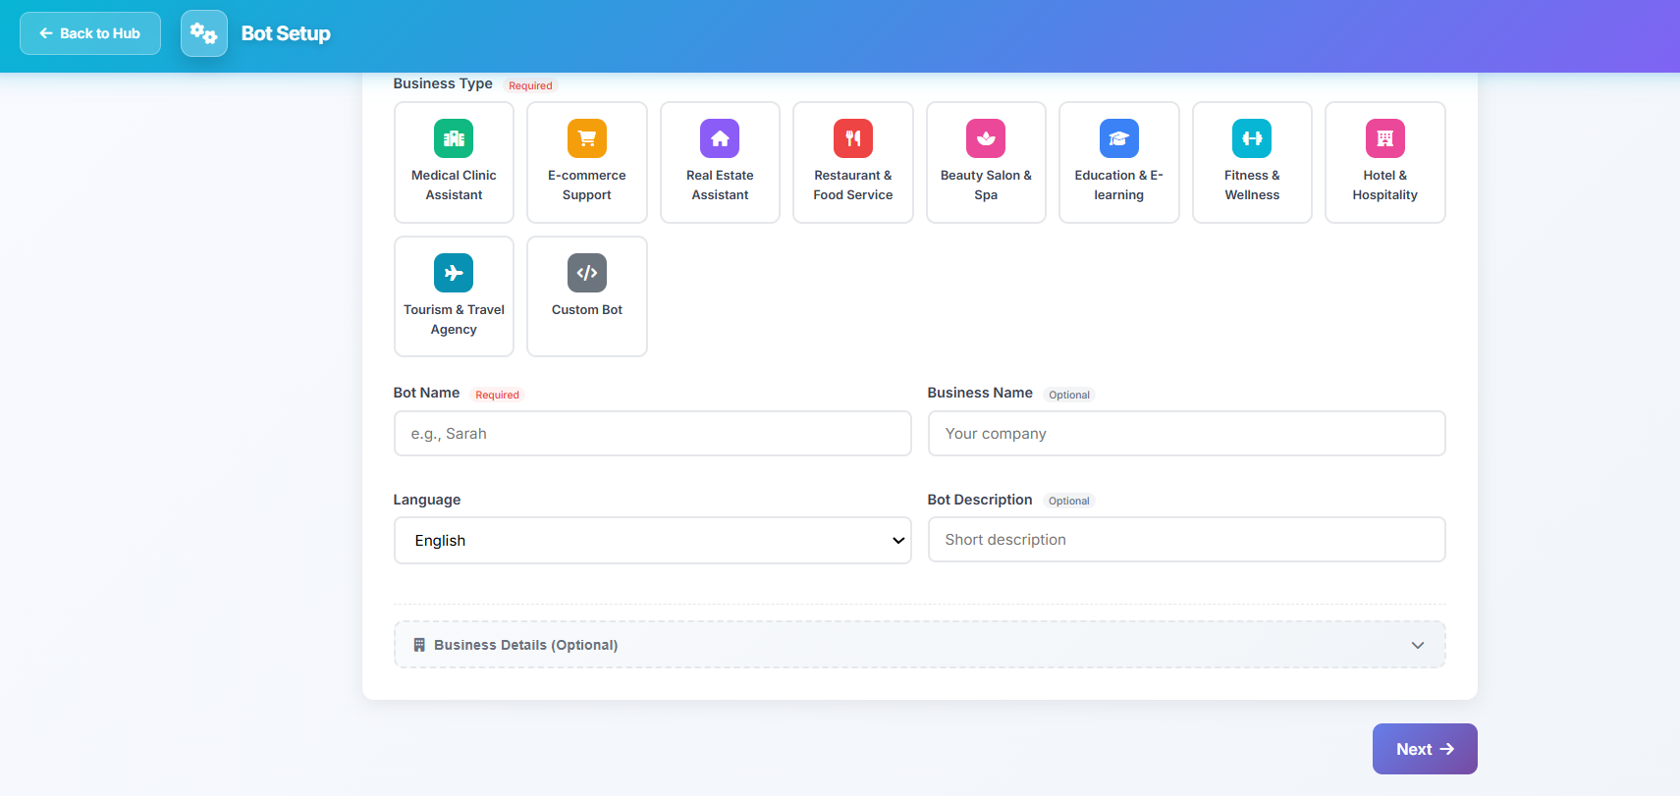

After that, set the Bot Response Style, review the Welcome Message, and choose the AI Model the bot will use to reply to customers.
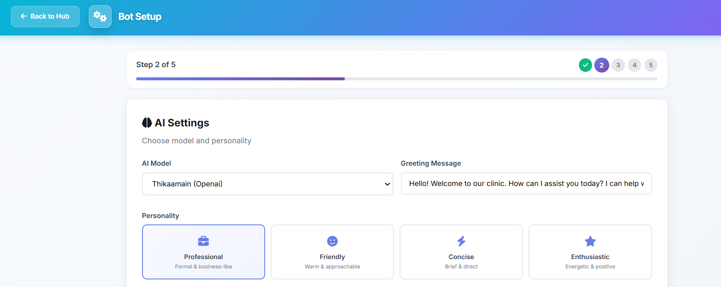

Then choose the Escalation Keywords Count. These are keywords that, when the customer types them, will trigger transferring the conversation to a human agent. After that, write the Escalation Message that customers will see when the chat is handed over.

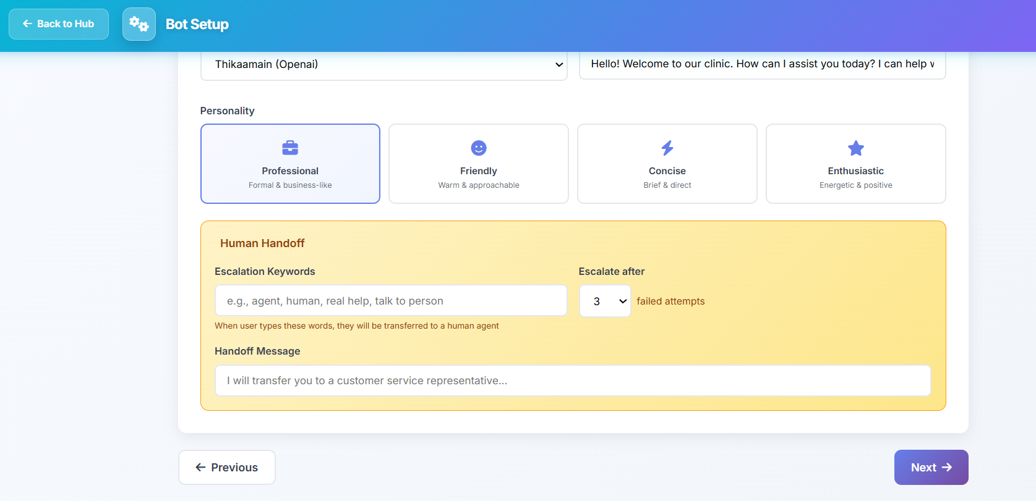

After completing the basic setup, add the Questions and Answers you want the bot to know, and train it on them.
Alternatively, you can click “Generate with AI.”

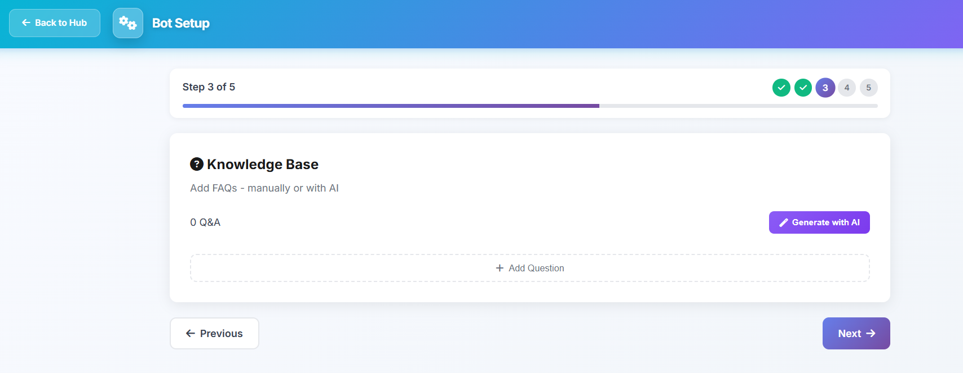
If you choose AI generation, enter your business and service details, then click “Generate with AI” so the system can suggest relevant questions.
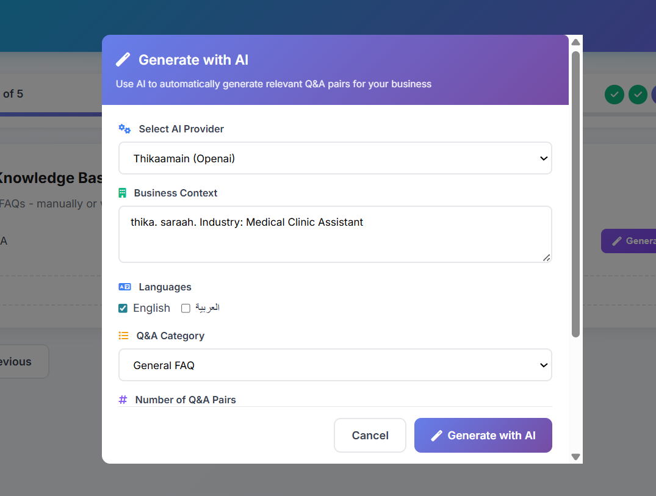

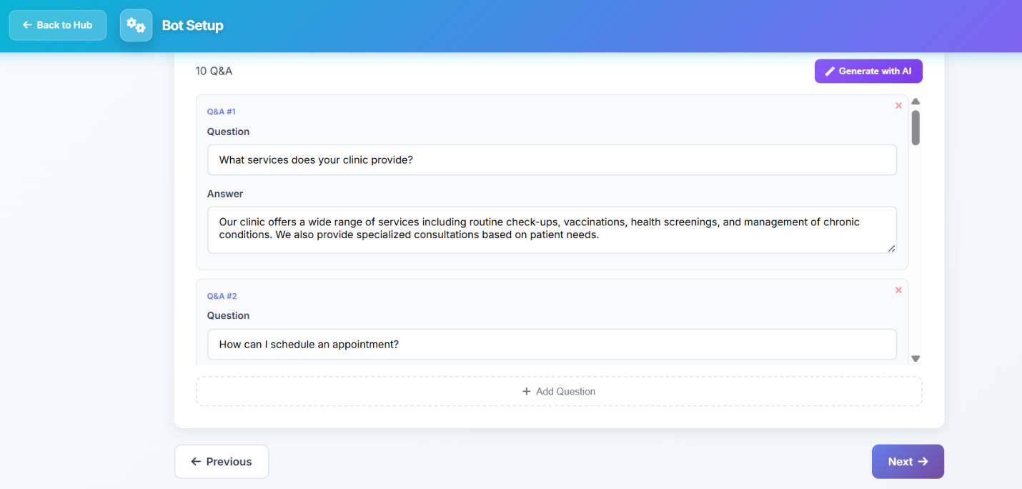
Once the questions appear, review them carefully, edit or add what you need, then click Next.

Finally, review everything one last time and click Create Bot.
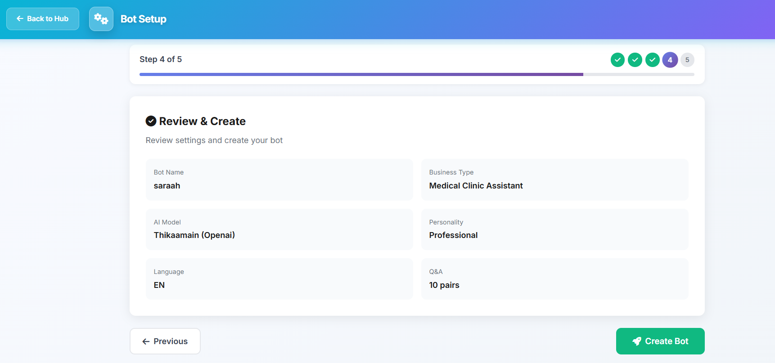

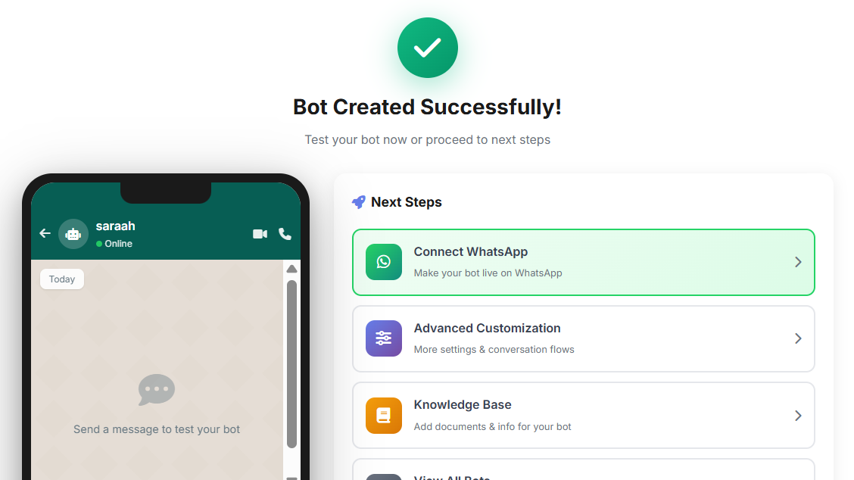
When the confirmation message appears, your bot has been created successfully.

