How to Create a New Bot
Advanced Setup (Quick Guide)

- To create a new bot, go to the Bot Center, then choose Create New Bot.

- 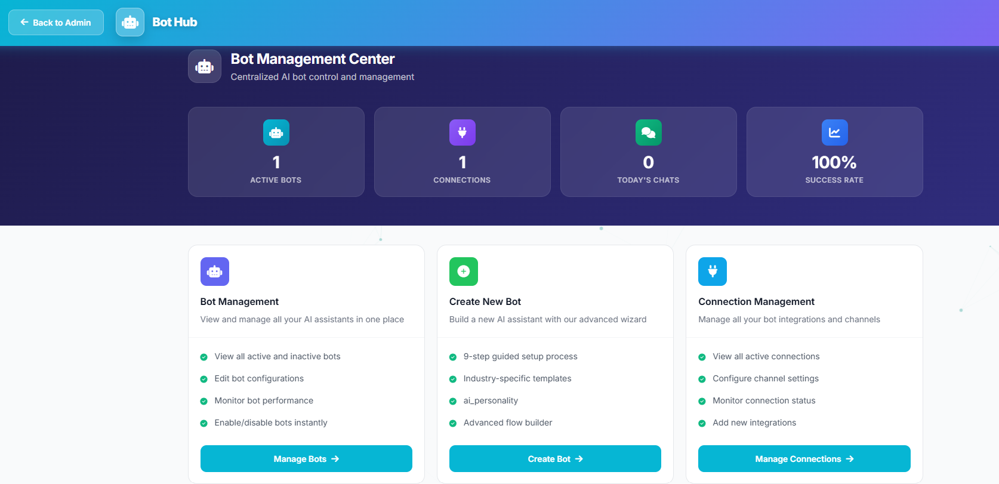

- Next, select Advanced Setup, and note that the more setup steps you complete and the more training data you provide, the better the bot will perform.

- 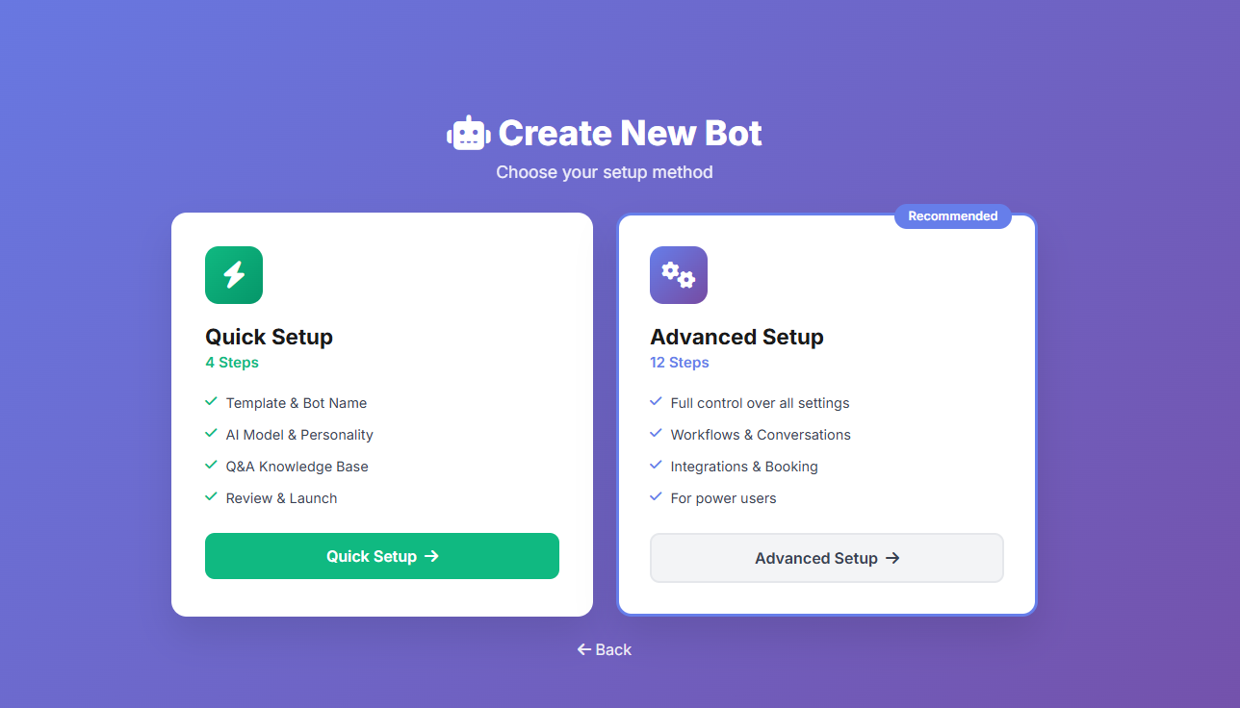
- Then choose the template that best matches your business and the services you offer,

- 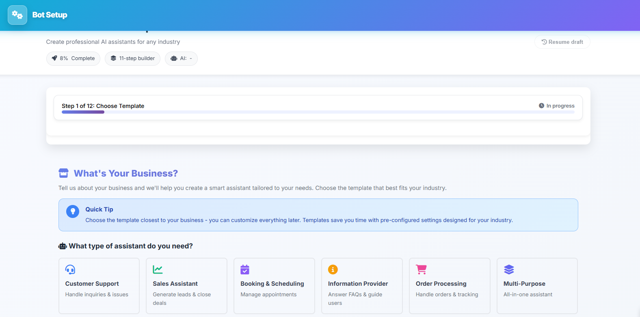

and select your business/company type.
- 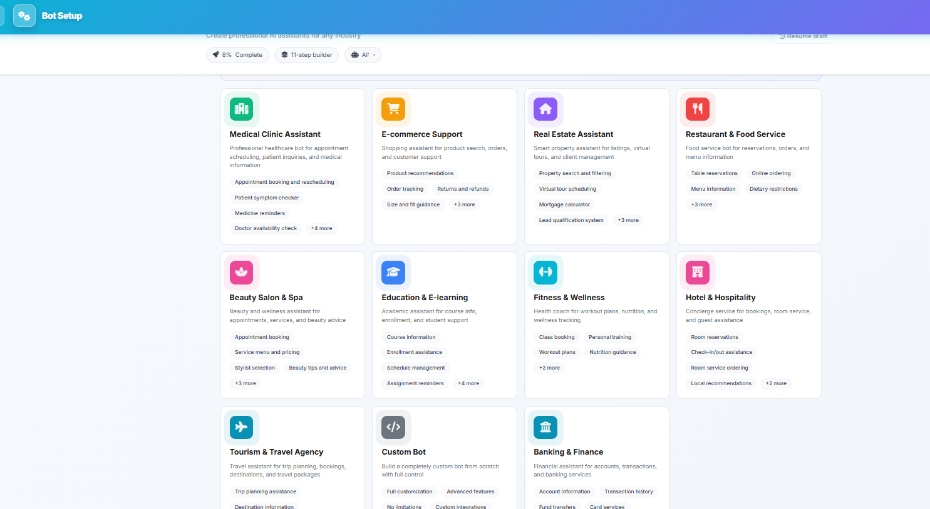

- After that, fill in the bot’s basic information you want to configure, such as limits and general settings.

- 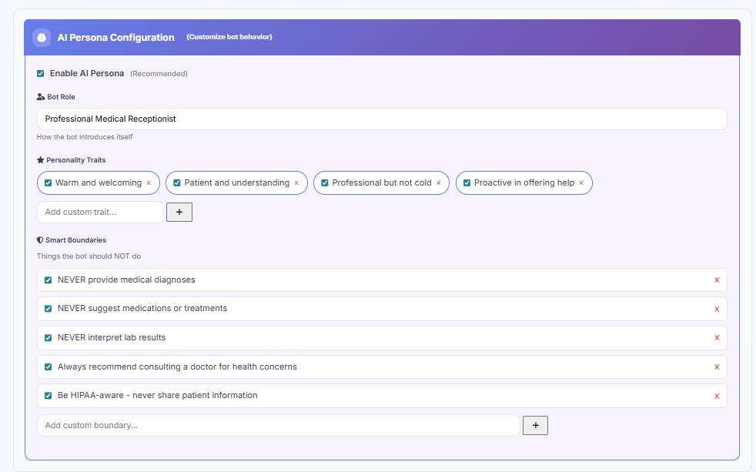

- Then write the bot’s details (name, description, and a welcome message for customers). If you do not have ready text, you can use “Generate with AI” to help you draft suitable content.

- 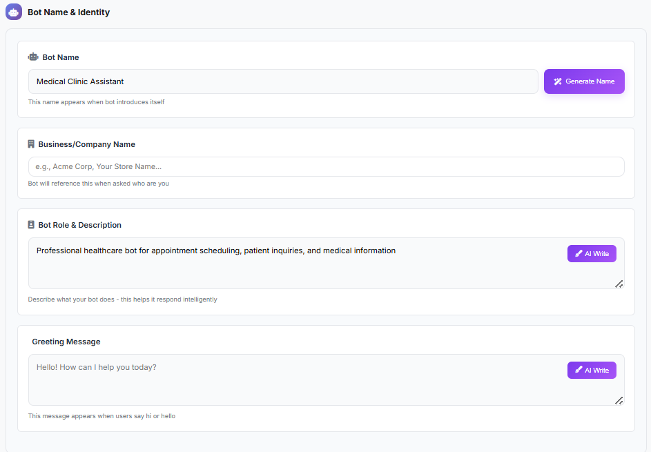

- Next, define the bot’s capabilities and the role it will focus on, and choose the language the bot will use to reply to customers.
- Then set the bot’s response style for customers, as well as the response speed.

- 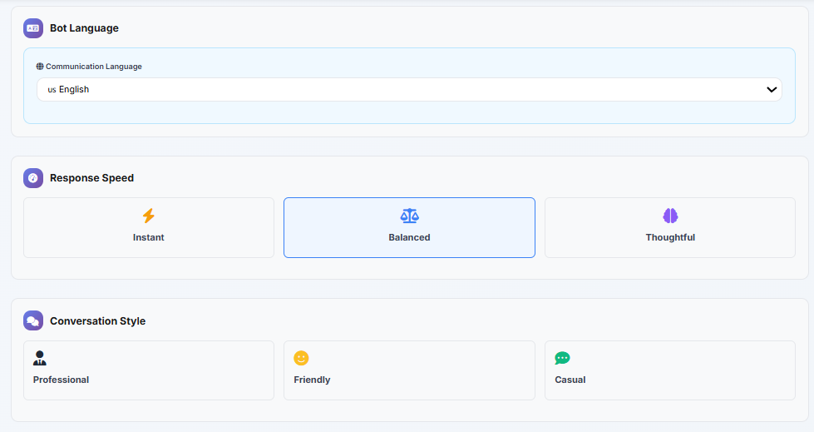
- At this stage, you can define the conversation flow between the bot and the customer within a specific structure using Conversation Flows.
- 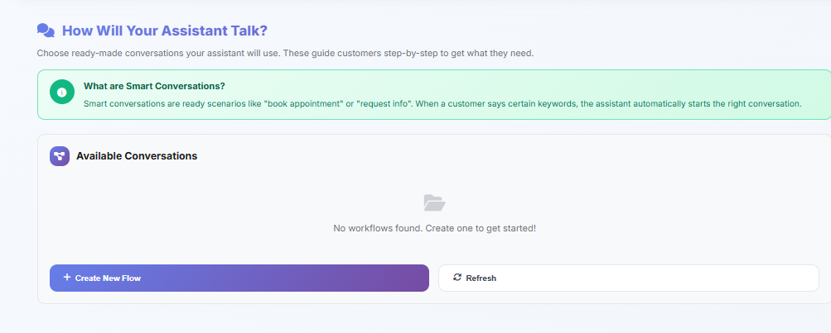
- After that, set the bot’s working hours and the time zone it will operate in.
- 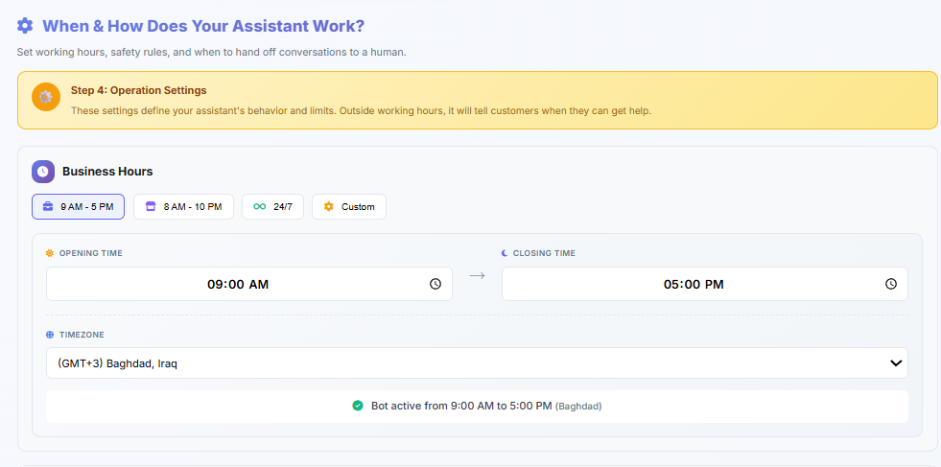

- Then configure error handling and the related error-handling messages.
- 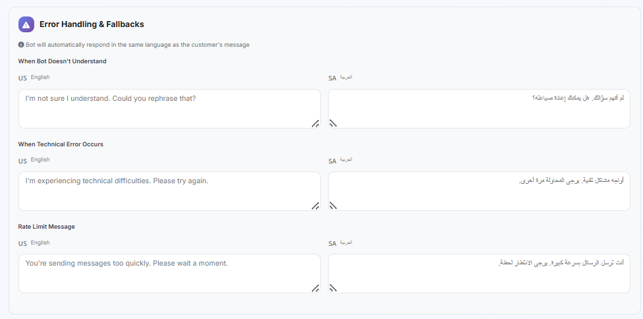

- Next, set the maximum number of failed replies, define the escalation keywords that will transfer the conversation to a human agent when customers type them, and then choose how the escalation message will be delivered.
- 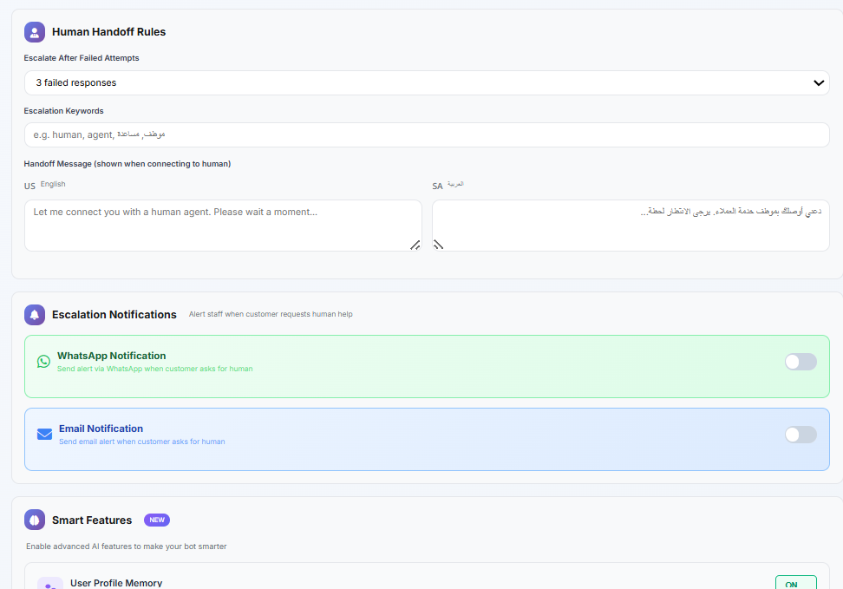

- Then add the Frequently Asked Questions customers are expected to ask, along with the appropriate answers. If you do not have enough questions, you can use AI to generate them.
- 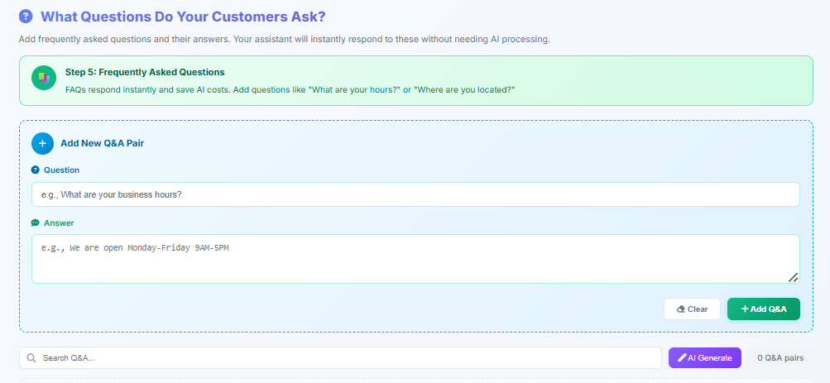

- After entering your company information, click Generate, and a confirmation message
- 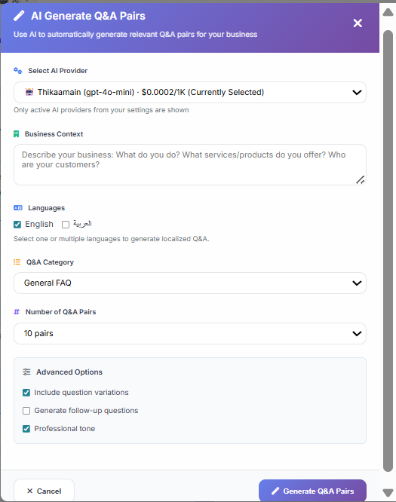

- will appear once the content generation is complete.

- 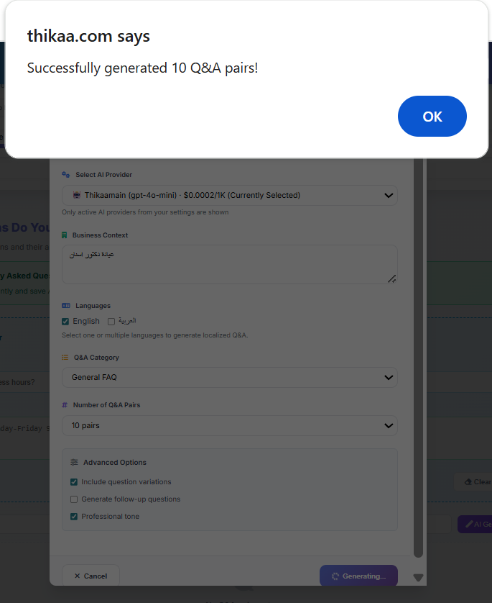

- Next, carefully review the questions and answers. If you want to add a new question, add it, then click Next Step.
- •
- 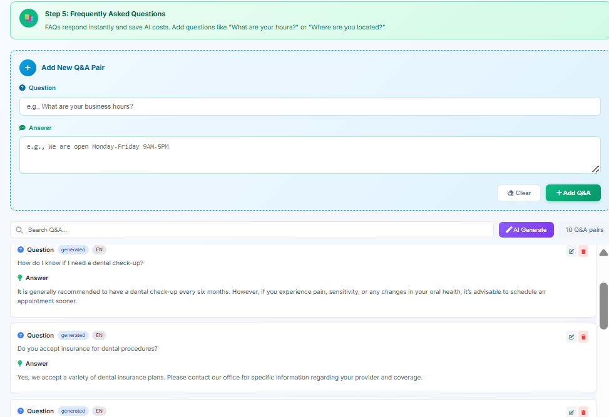

- Then you can upload knowledge sources that the AI will use to reply to customers.

- 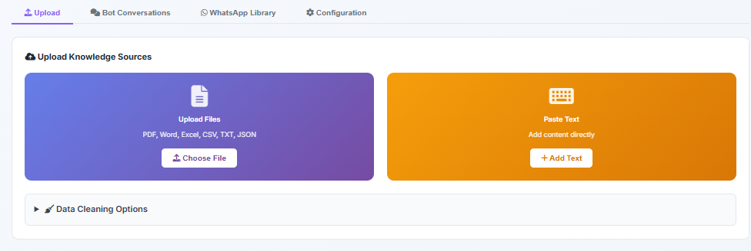

- After that, set your priorities in a way that fits your business needs.

- 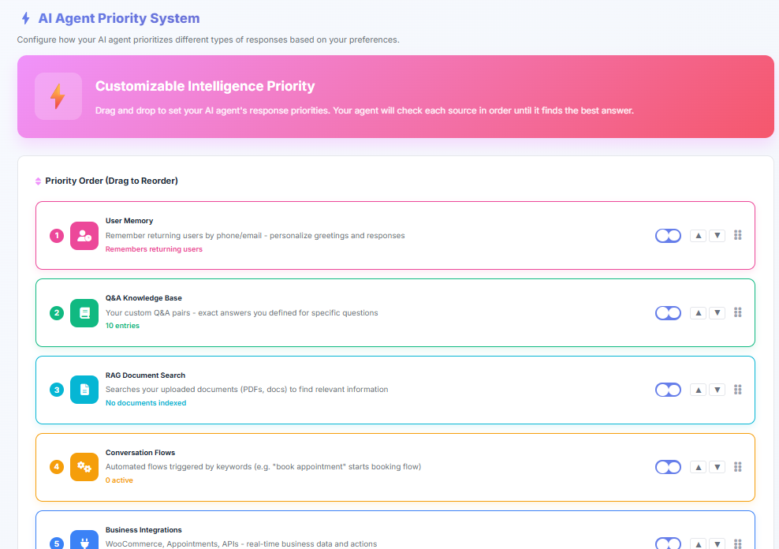

- If you want the bot to be able to book appointments, enable this feature.
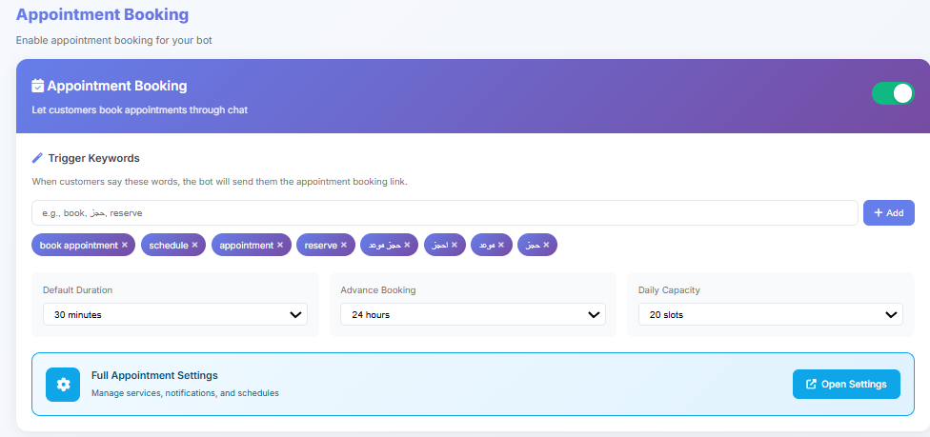
- Then you can run a test chat to thoroughly test the bot before saving.

- 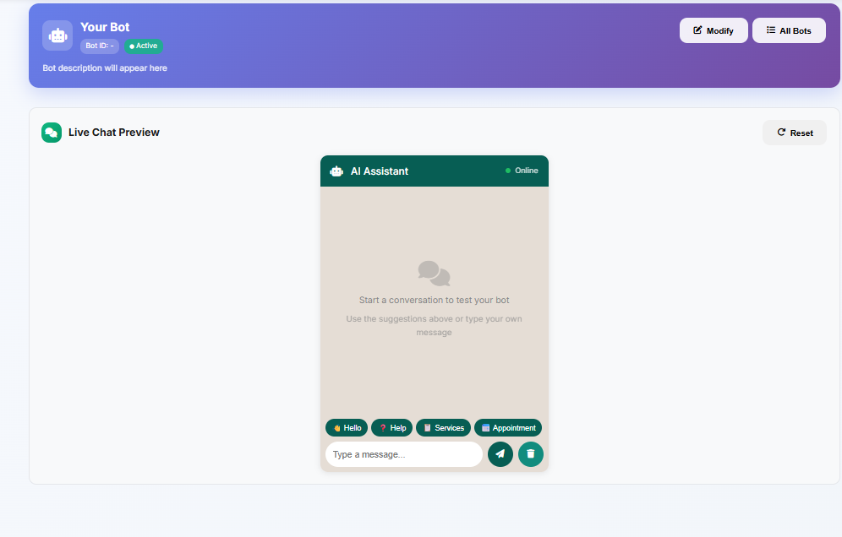
- Next, review the information. You will see the bot’s completion percentage before activation, and once finished, click Connect Bot.
- 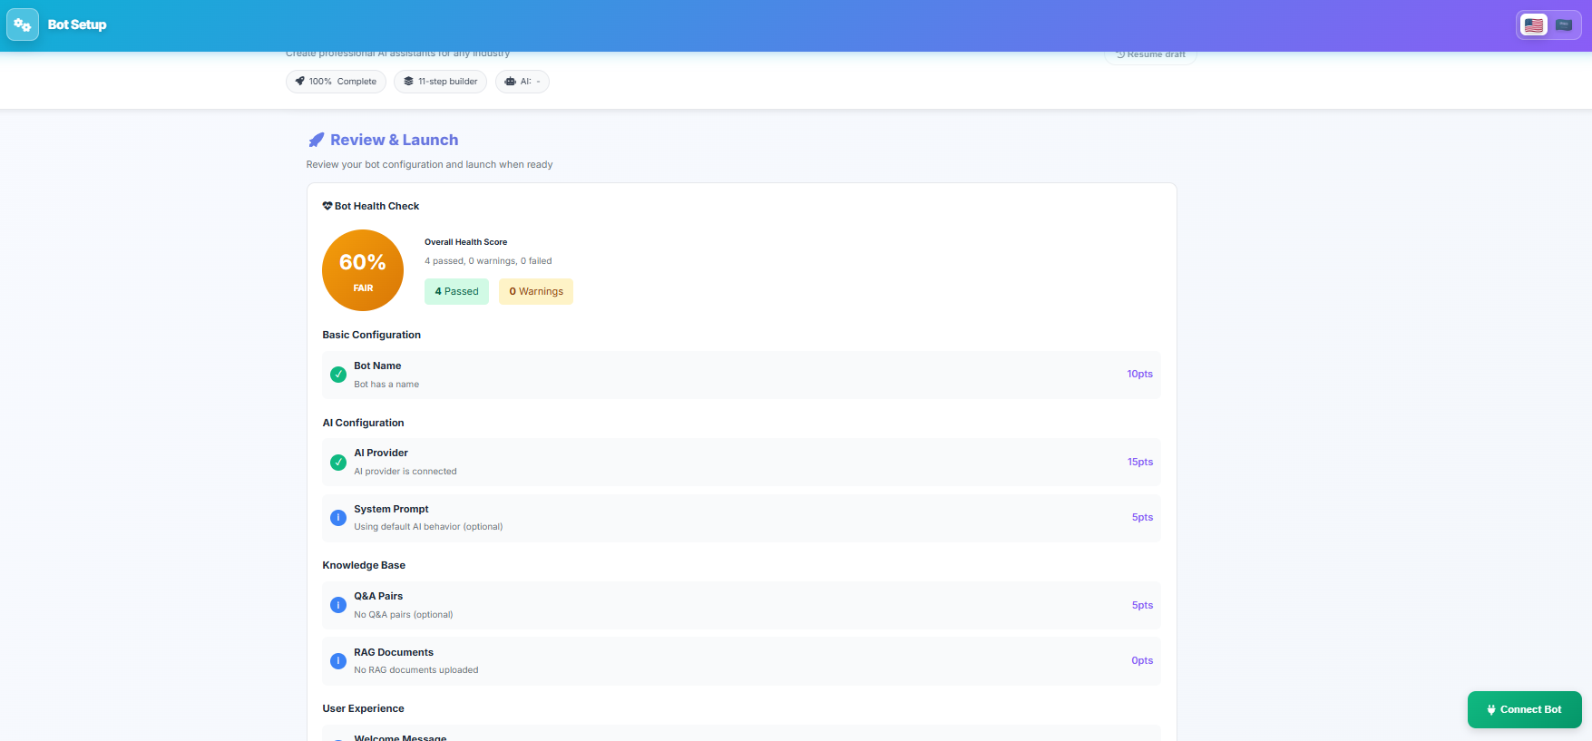

- Finally, connect the bot to the pages and channels where you want it to be active.

- 